Fixing the wiki problem:

Go to the Word Norms 2 folder in the res lab drop box folder.

Open up the 1.5 raw words no wiki folder (it will be full when we get to this part).

Open them in TextEdit for windows or TextWrangler for Mac

* Textpad: <http://www.textpad.com/download/index.html>
* Textwrangler: <http://www.barebones.com/products/textwrangler/>

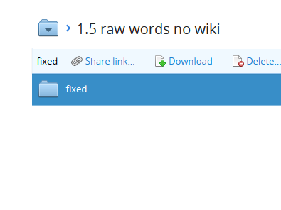

Open up a file (this one is boss).

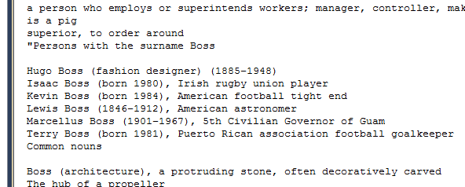

You are looking for things that are obviously formatted like an online dictionary, so look for lists of things, or numbered/lettered lists.

You can also tell by the “quote” marks … but that’s not a hard and fast rule, sometimes they are there, but aren’t a problem.

Delete all the Wikipedia looking stuff.

Delete anything that says I don’t know IDK or something like that.

Please note that these wiki copies will be really big sections, so don’t feel like you are doing something wrong by deleting that much. Most people wrote one/two lines of stuff, so something that big is a copy/paste.

Save the file in the fixed folder. Move the copy, so we know what words we have left.

OLD NOTES

Spell checking:

Go to the Word Norms 2 folder in the res lab drop box folder.

Open up the 0.5 need to check.

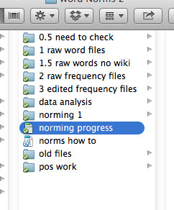

Look at all those words:

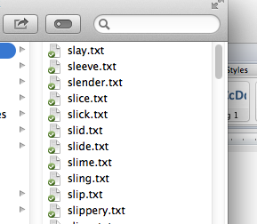

Open them in TextEdit for windows or TextWrangler for Mac

* Textpad: <http://www.textpad.com/download/index.html>
* Textwrangler: <http://www.barebones.com/products/textwrangler/>

MAC:

Go to text > find all misspelled words.

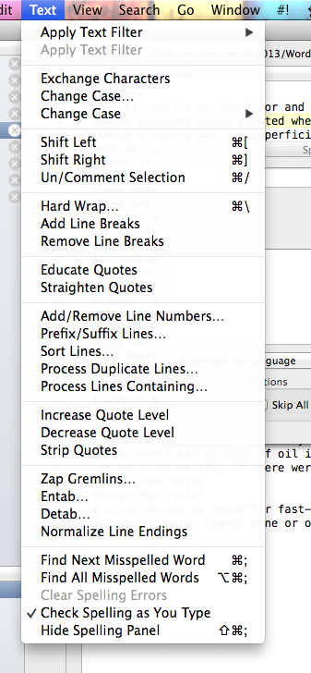

Windows:

Click the check mark abc button.

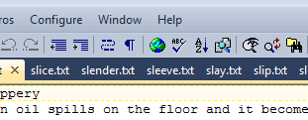

Or tools > spelling.

You may want to hit options:

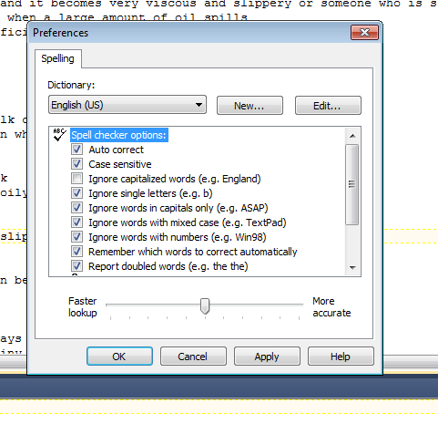

Turn off case sensitive, and report double words.

Fix all the words that are misspelled!

Move them to the 1 raw words folder (move don’t copy).

IF THE FOLDER IS EMPTY LET ERIN KNOW. I WILL EMAIL YOU WHEN WE ARE READY FOR THIS HALF.